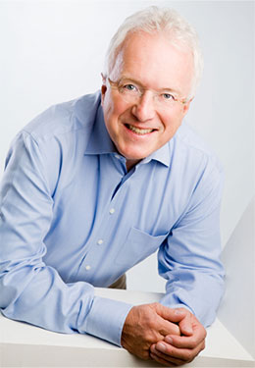 | 27.08.2015 the teachers of our school attended "Aiming High with Super Minds" seminar in Kyiv, presented by Herbert Puchta – a well-known tutor , scientist and author, who was the president of International Association of Teachers of English as a Foreign Language (IATEFL).  In this session, Herbert demonstrates how we can enrich learners’ language learning engaging them in  real-world thinking tasks.
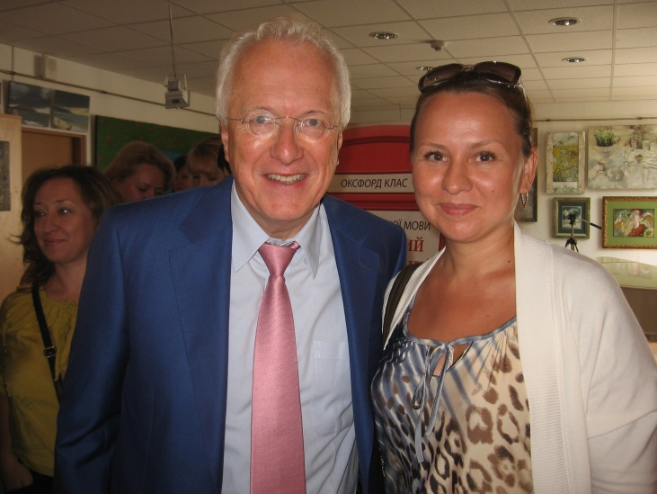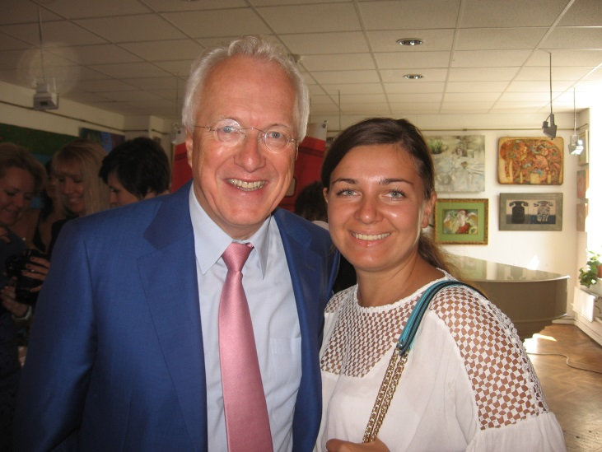
In the second part of the session, Lana Sushko and Talia Lyashko – the authors of "Lessons plus for Ukraine", showed how to deal with grammar in the primary school. They provided our teachers with a handful of activities and ideas which may make the lessons even more involving, physical and fun.
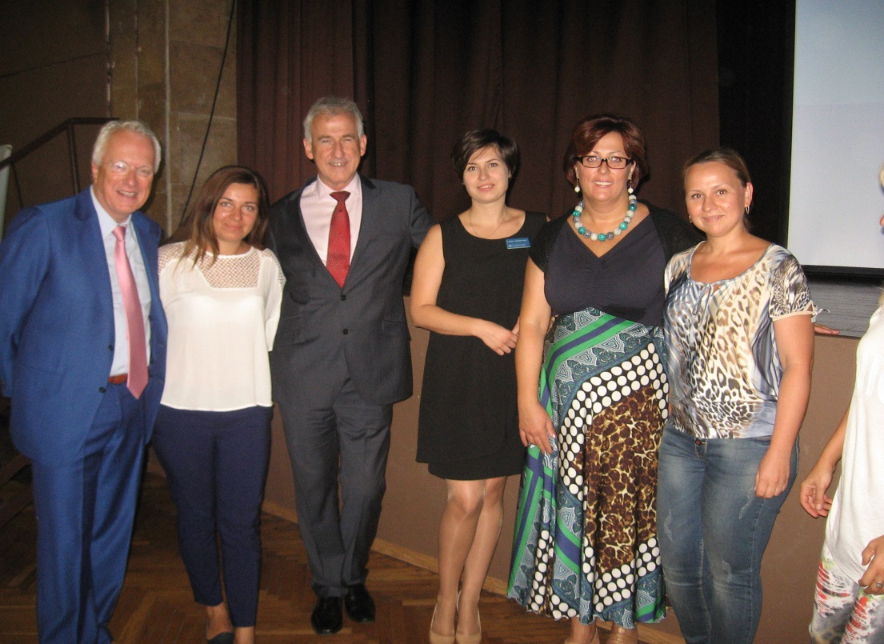

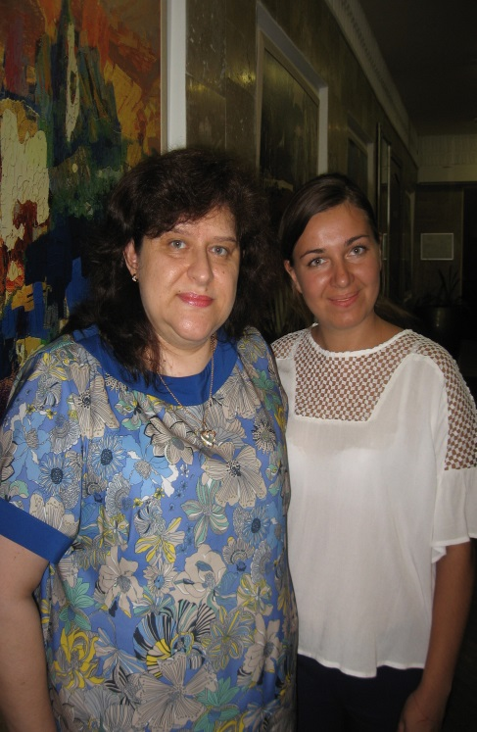 | An unexpected bonus was meeting Alla Nesvit – the Ukrainian author of English books, who is going to support us in teaching. | 